- Configure VPC peering in cross regions.
I have created one pub server in North Virginia region
I created one more Instance in Ohio region.
I am just creating peering connection between two regions.
One main condition is The CIDR range, Will not overlap. (I faced this issue so, I just changed the CIDR range.)
I created peering connection from N.Virgina region and try to accept it from Ohio region.
After this, We need to route this peering connection in both of the regions using CIDR range.
Now, Once try to login N.Virgina region server into local then ping the ohio region region server with the instance private IP.
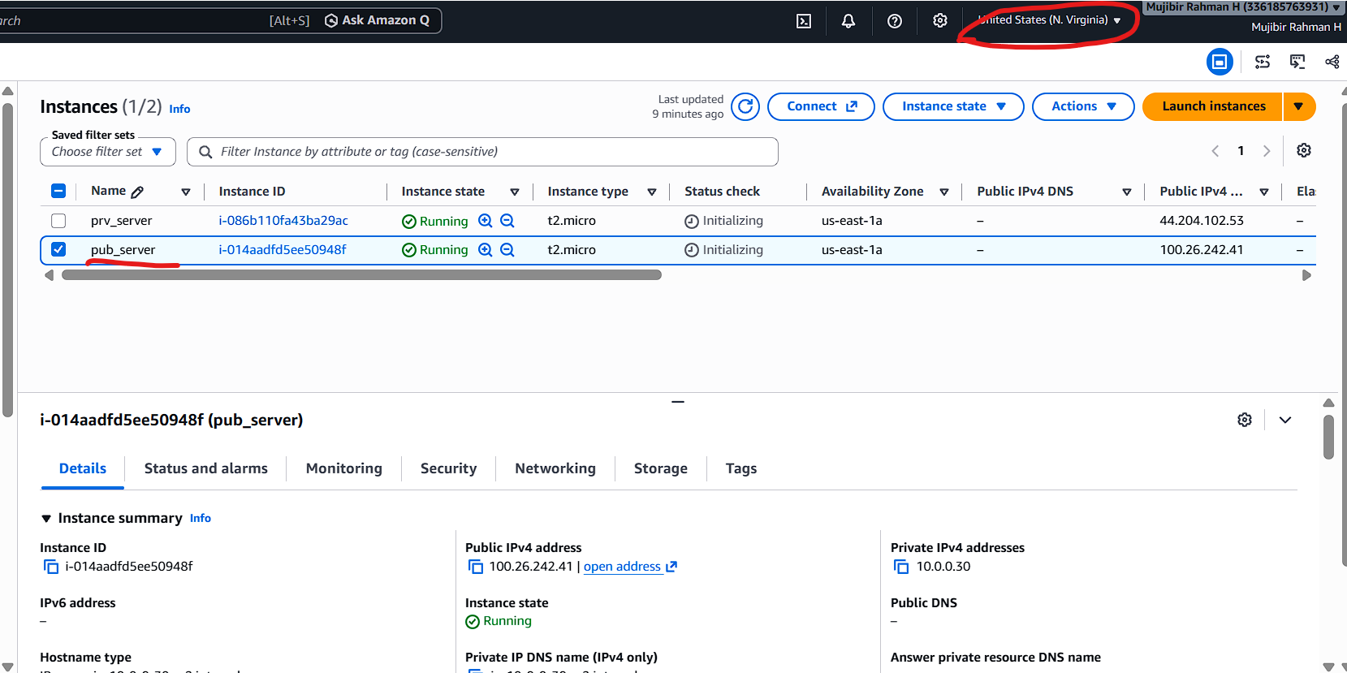
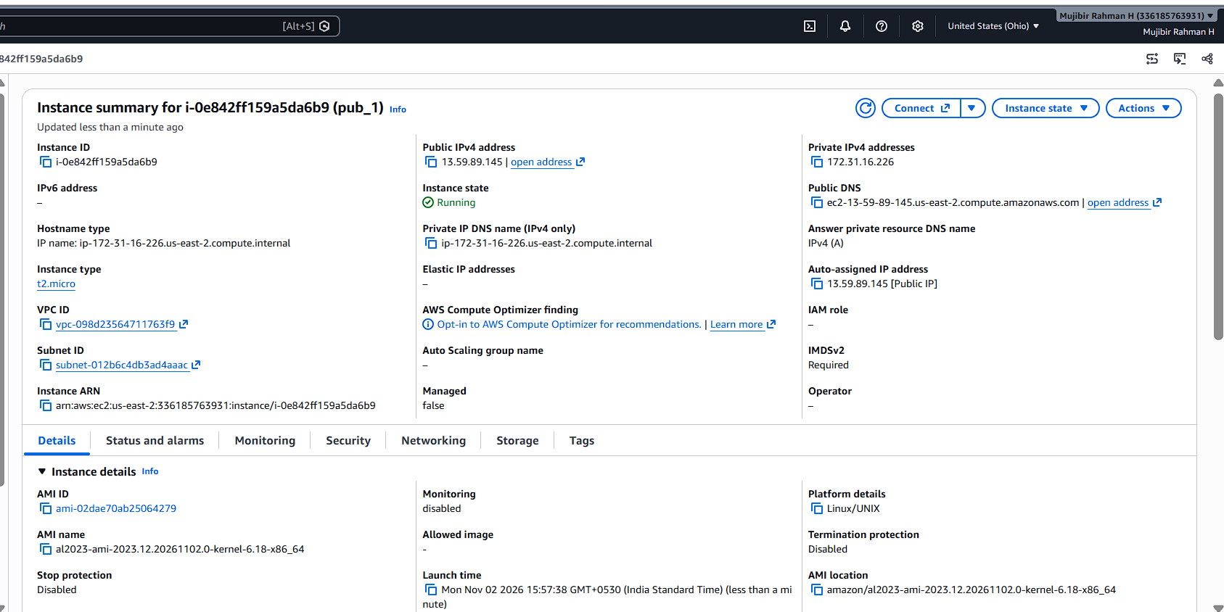
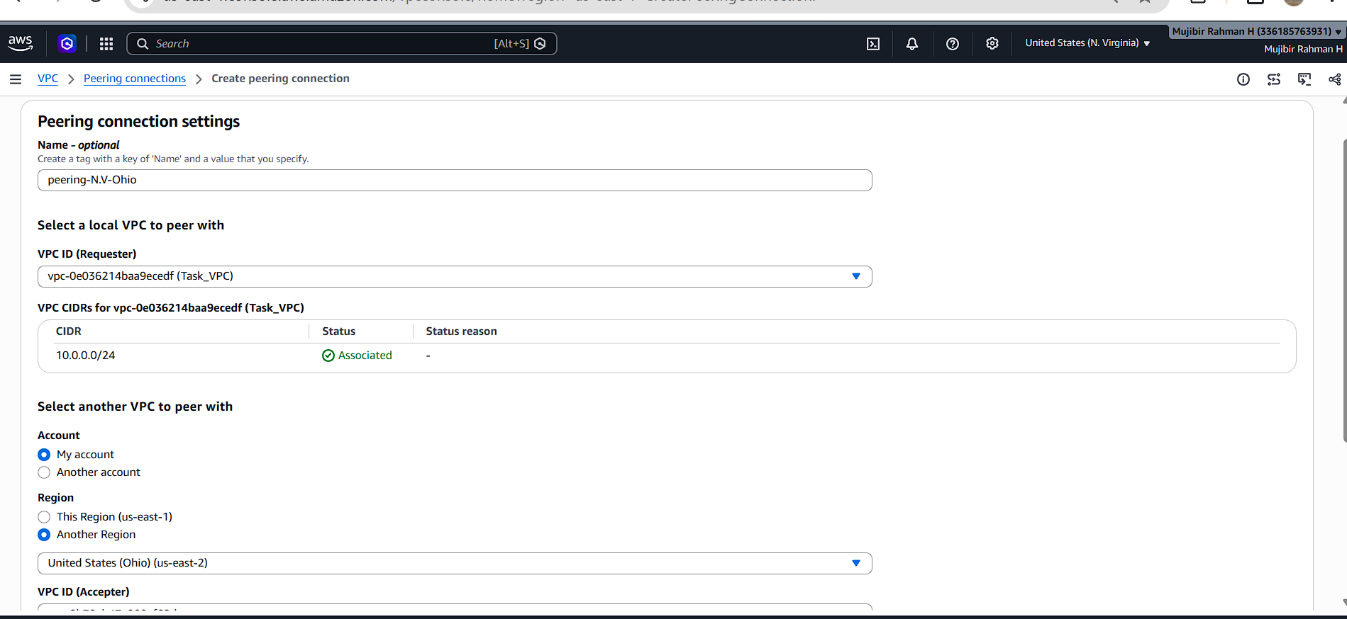
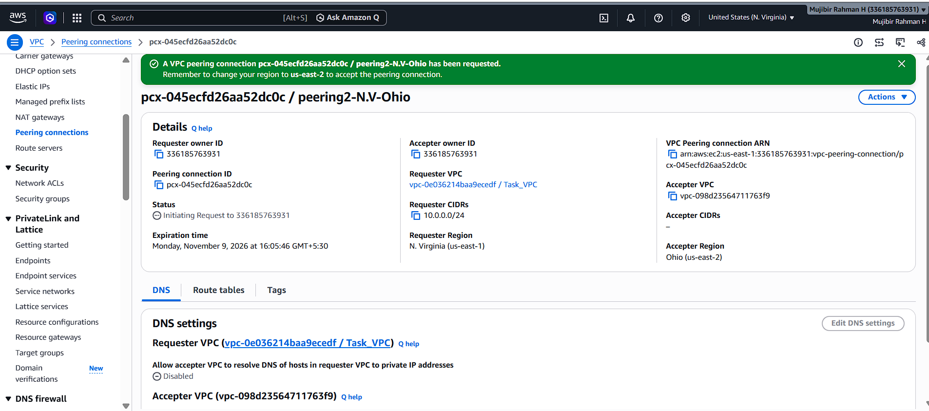
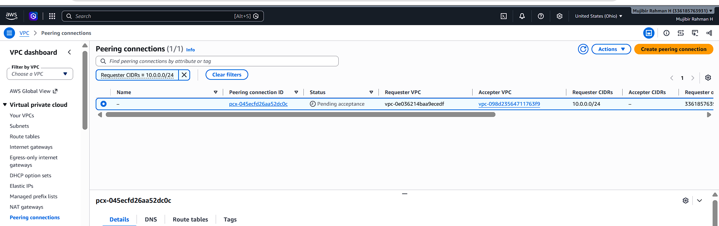
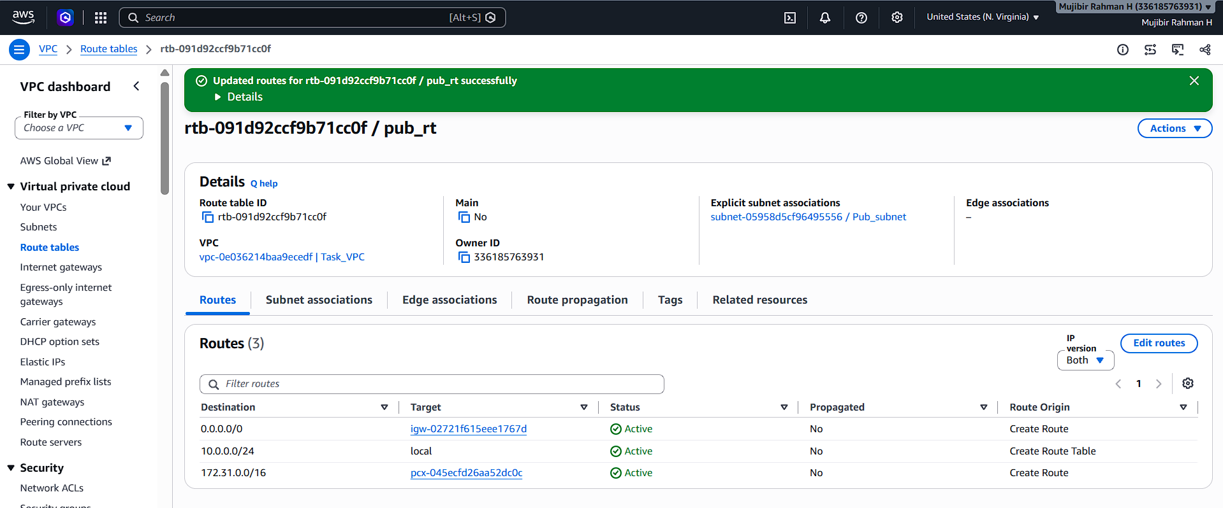
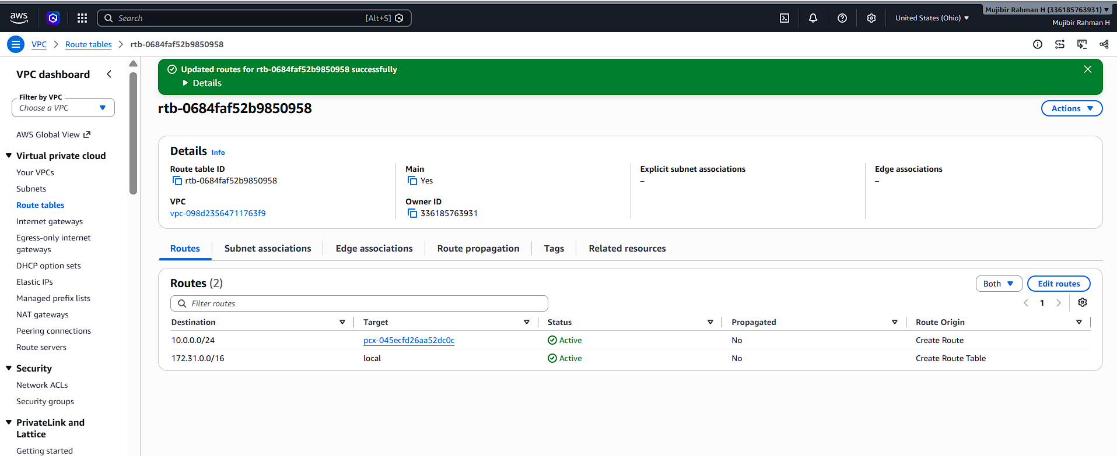
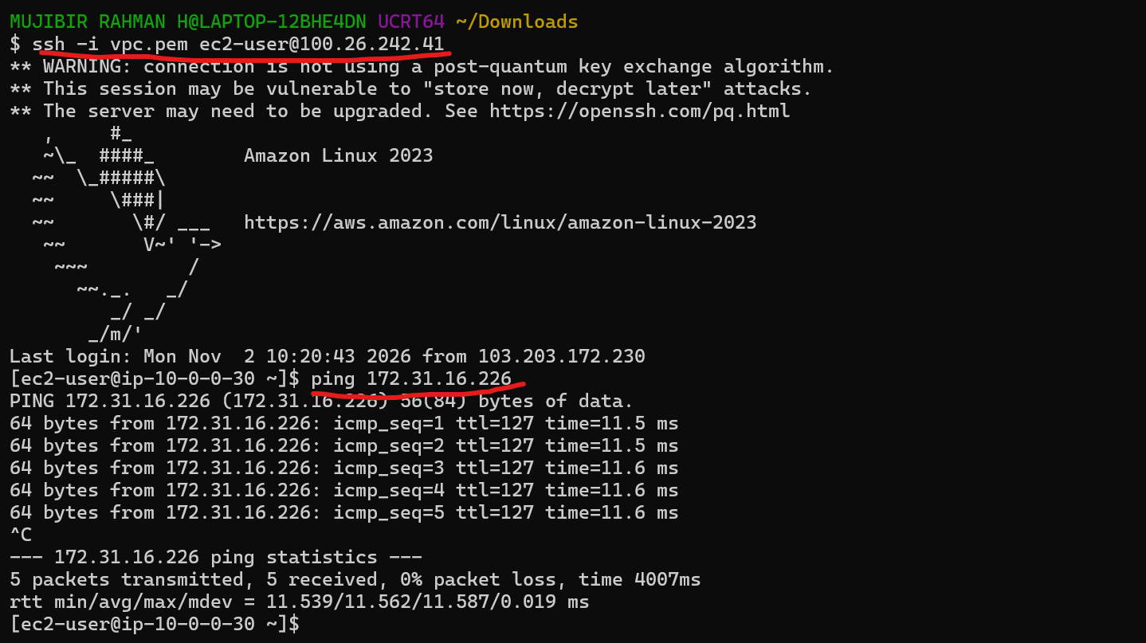
- Purchase one domain from GoDaddy.
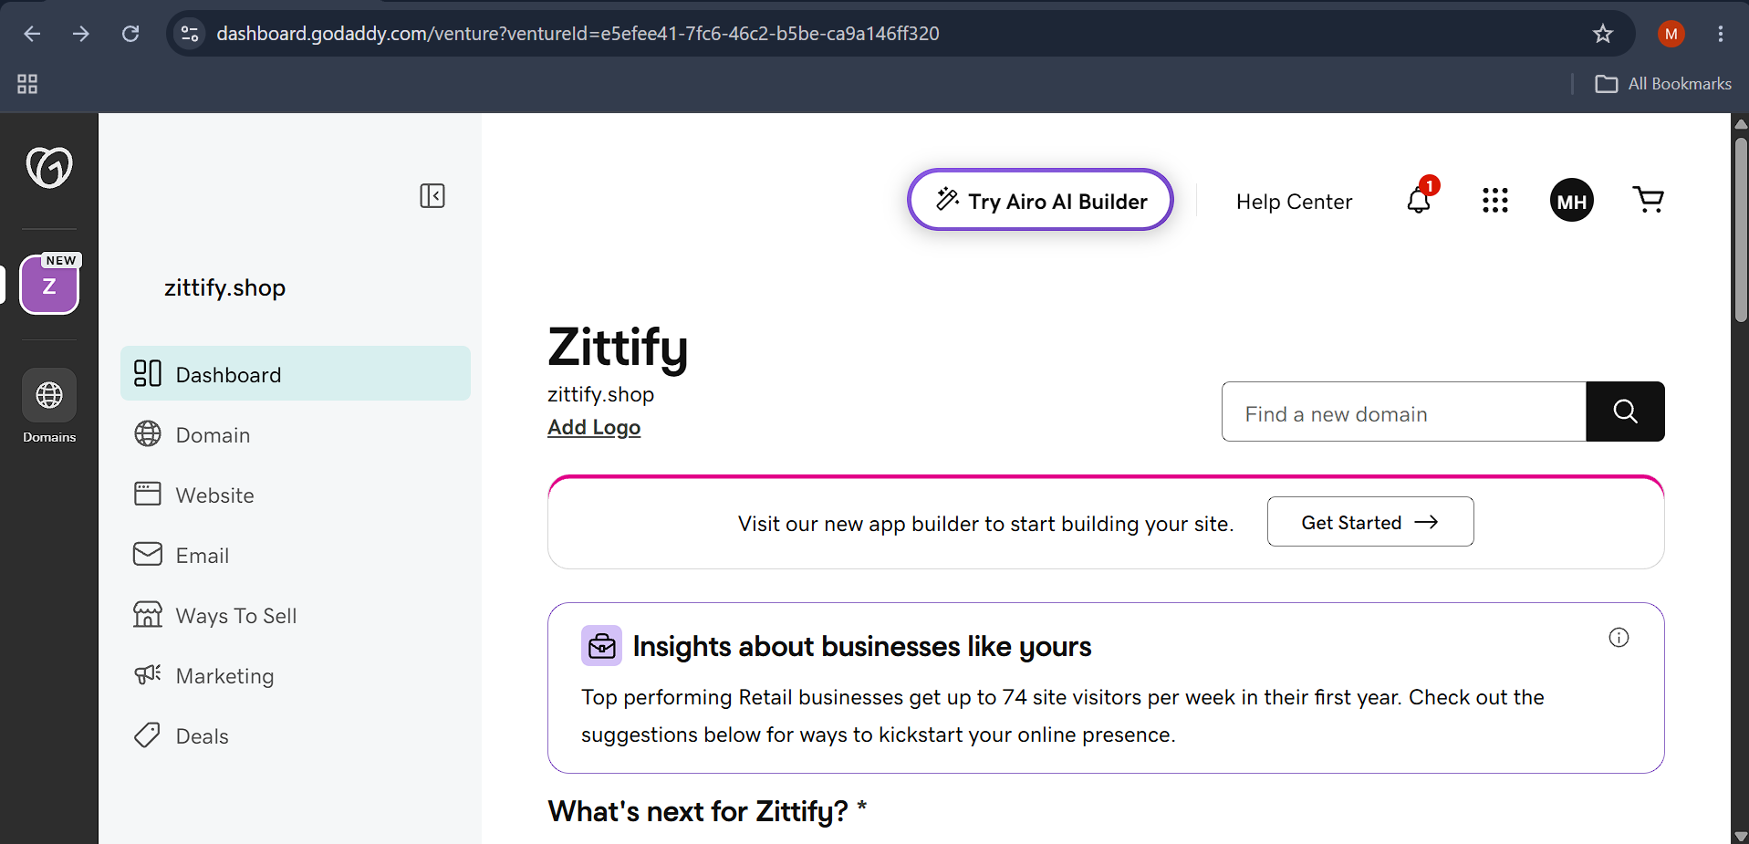
- Deploy static website in S3.
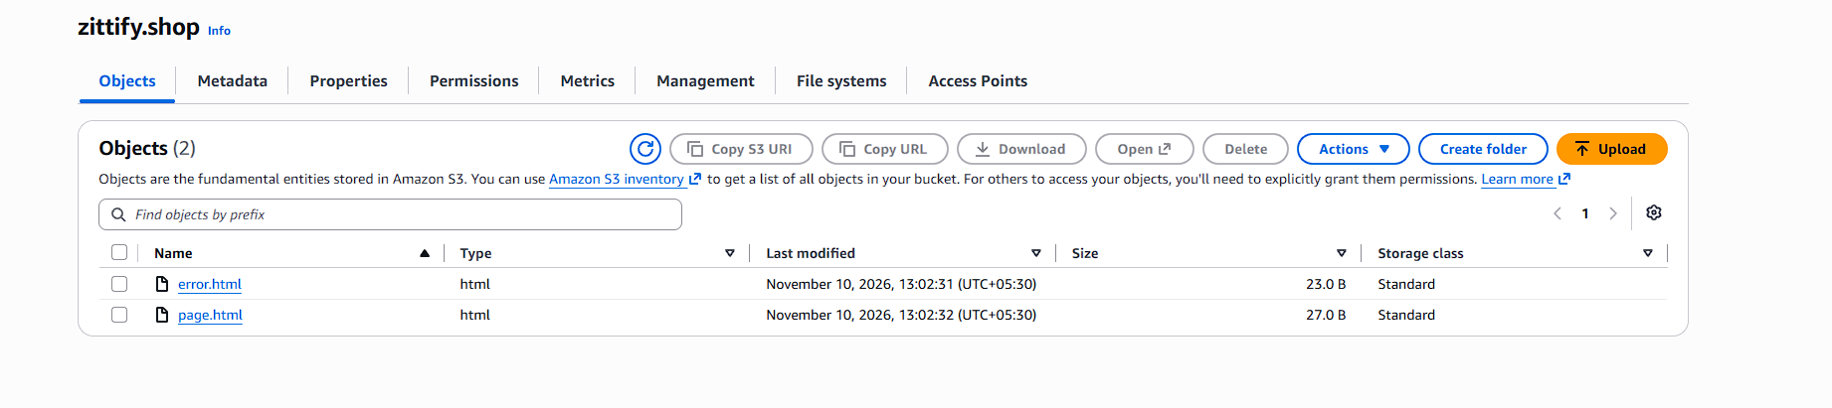
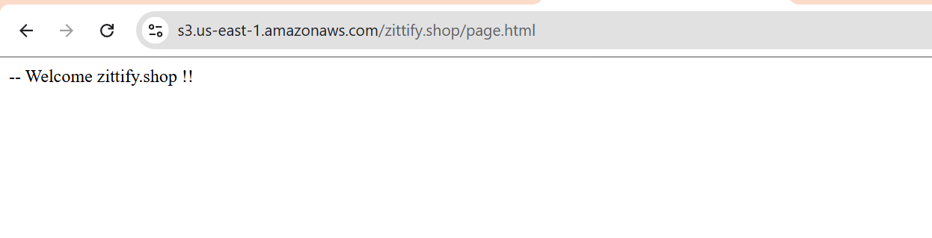
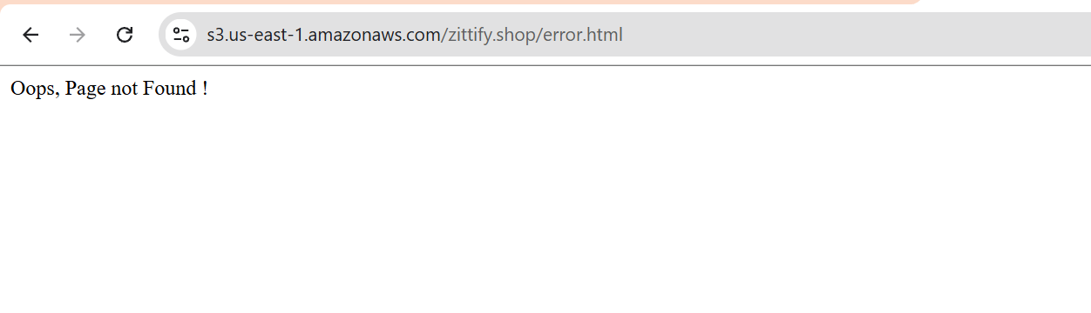
- Create a CDN and attach one SSL certificate.
I just configured the distributions in cloud front and created the records in R53 for that distribution. Attached the SSL cert and sub domain name in distribution.
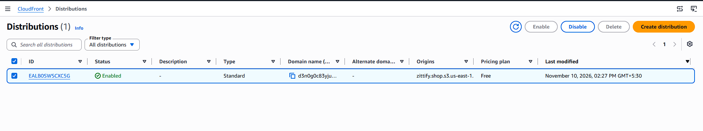
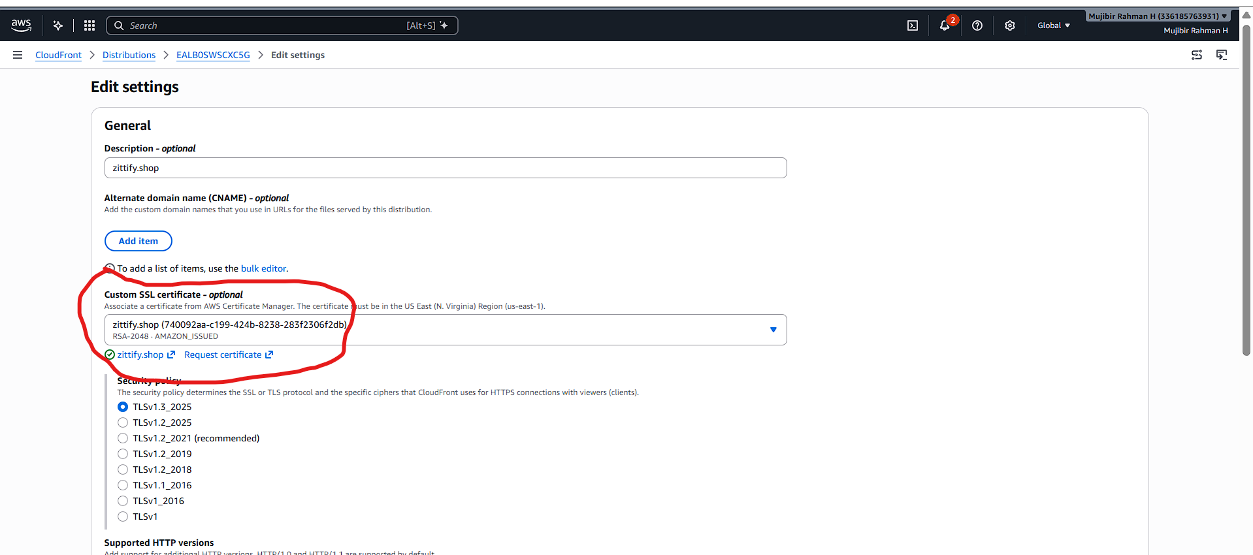
- Create a Route 53 hosted zone and map the domain with the CDN.
After configured the SSL cert in cloud front distribution, I tried to create one more record for adding the cloudfront distribution in R53.
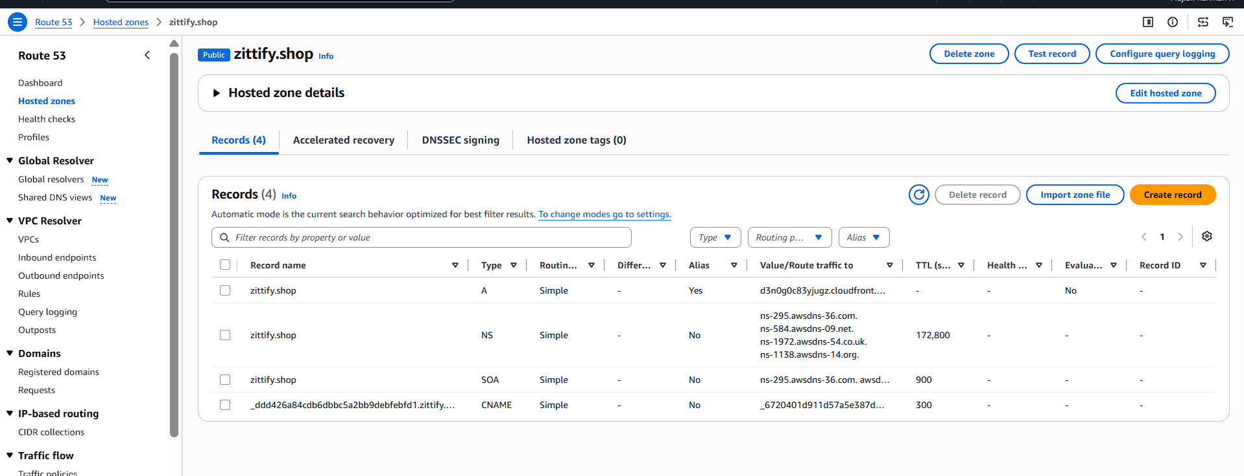
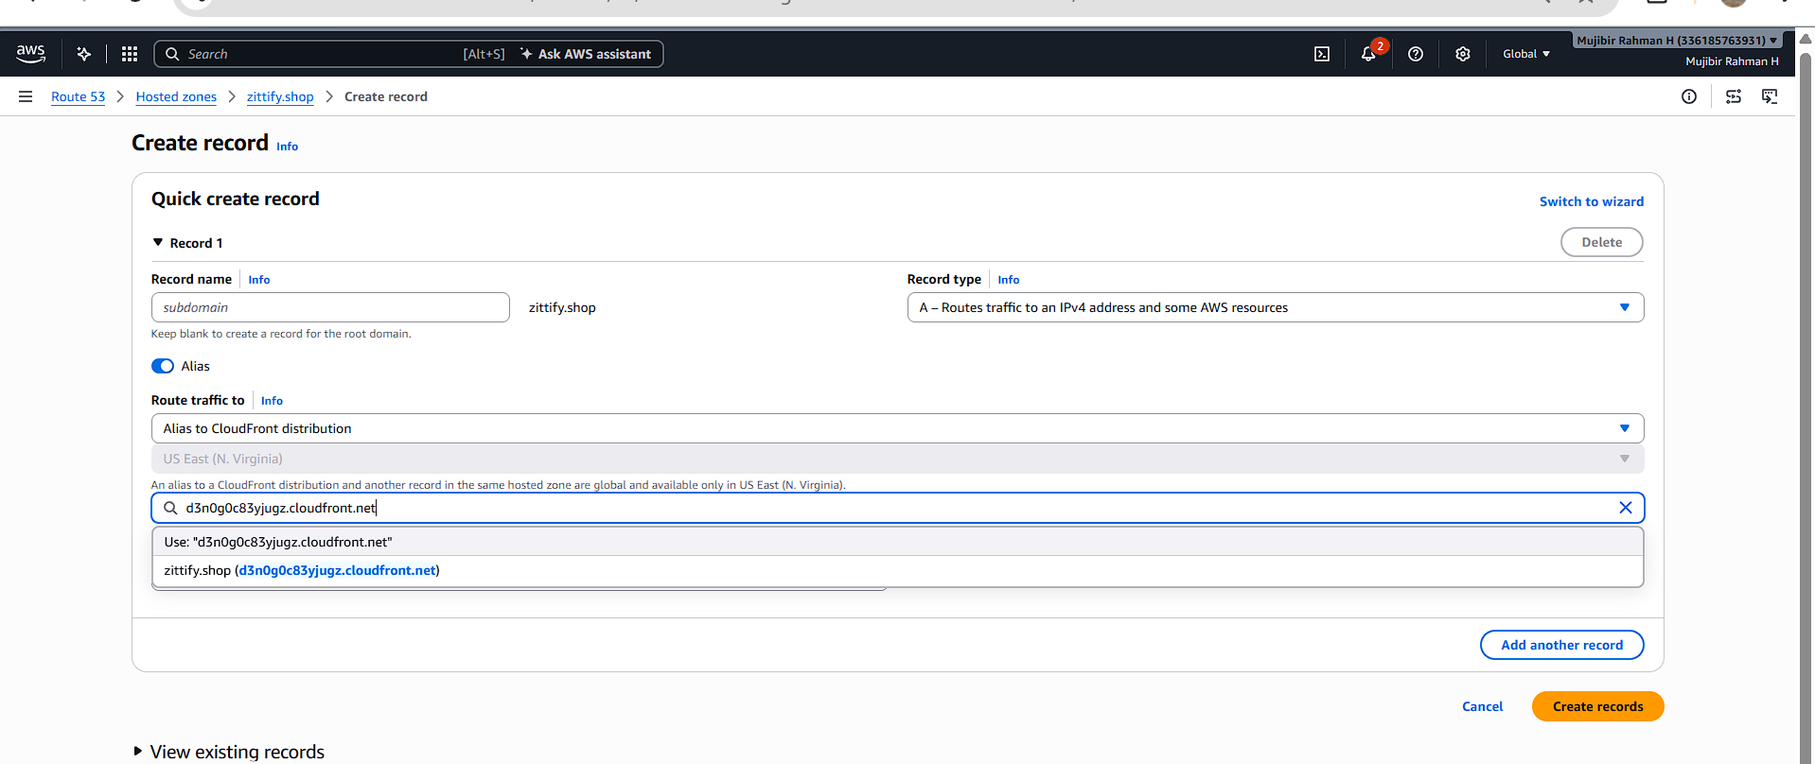
- Update the index.html in the S3 bucket and ensure the updated file is accessible using the domain name.
I just tried to access my zittify.shop url –It’s redirected from http to https.
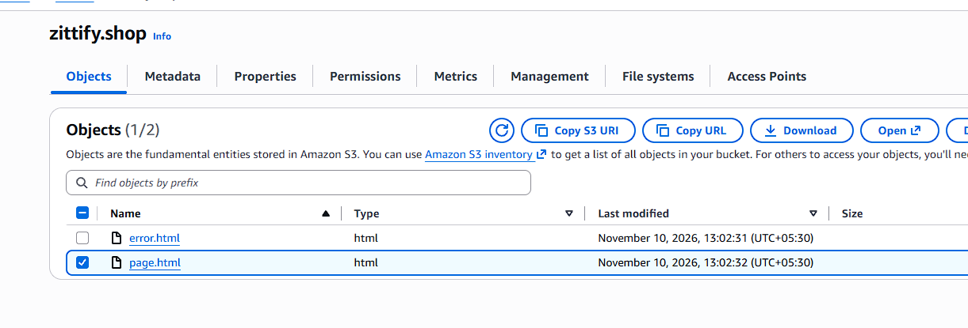
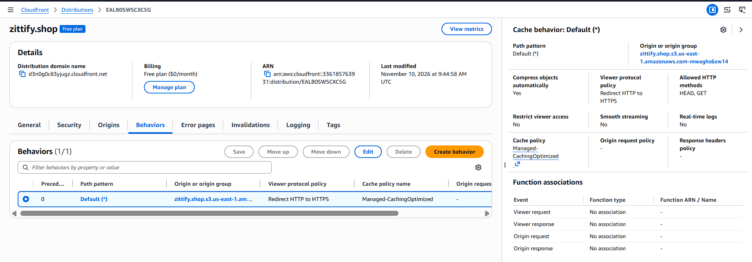
Here, In above picture, I redirected the behaviour from http to https.
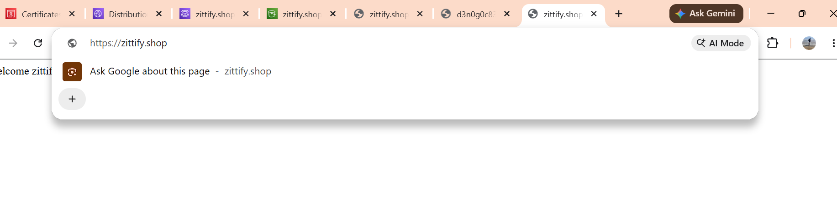
- Share the domain name in Slack to test the connectivity.
https://zittify.shop/

